实验编号： 11 **四川师大《IOS》实验报告 2019** 年 **12** 月 **12**日

### 计算机科学学院 2017 级 4 班 实验名称： 多MVC _

姓名： 李晋 学号：2017110517 指导老师：李贵洋 实验成绩:

### **实验11 多MVC**

**一、实验目的**

1. 掌握多MVC的设计以及实现；
2. 完成苹果官网的FoodTracker全部内容；

**二、实验要求**

1. 认真填写实验报告，要求附加部分运行界面和主要代码；
2. 对设计好的程序，检查输出是否符合预期，如有错请分析错误原因并解决；

**三、实验内容**

1. 实现一个简单的多mvc程序
   1. 控制器之间正向传参
   2. 控制器之间反向传参
2. 完成苹果官网的FoodTracker Demo（多MVC）
   1. TableView（自定制Cell）；
   2. NavigationController；
   3. Modal Controller;
   4. ImagePickerController;

说明：苹果官网Demo网址如下

<https://developer.apple.com/library/content/referencelibrary/GettingStarted/DevelopiOSAppsSwift/index.html>

**四、实验主要流程、基本操作或核心代码、算法片段（该部分如不够填写，请另加附页）**

**FirstViewController**

// YellowViewController.swift

// myNavigationController

//

// Created by student on 2019/11/28.

// Copyright © 2019 2017110517. All rights reserved.

//

**import** UIKit

**class** YellowViewController: UIViewController {

**@IBOutlet** **weak** **var** firstTF: UITextField!

**override** **func** viewDidLoad() {

**super**.viewDidLoad()

print("first view DidLoad!")

}

//prepare函数在viewContrller切换之前执行

**override** **func** prepare(for segue: UIStoryboardSegue, sender: **Any**?) {

//11111.正向传参

**if** segue.identifier == "showSecond"{

**if** **let** secondVC = segue.destination **as**? BlueViewController{

secondVC.mytitle = firstTF.text

}

}

}

}

**SecondViewController**

//

// BlueViewController.swift

// myNavigationController

//

// Created by student on 2019/11/28.

// Copyright © 2019 2017110517. All rights reserved.

//

**import** UIKit

//33333.定义协议（自定协议反向传参）

**protocol** ParamTransDelegate {

**func** trans(mess:String)

}

//333333.继承协议（自定协议反向传参）

**class** BlueViewController: UIViewController,ParamTransDelegate {

//1111.自定义一个变量，接收上一个页面的参数

**var** mytitle:String?

//3333.自定义一个变量，接收后一个页面的参数（自定协议反向传参）

**var** tranMess:String?

//44444.自定义一个类保存参数，接收后一个页面的参数（自定类反向传参）

**var** secondParam:SecondParam = SecondParam(param: "")

**@IBOutlet** **weak** **var** tranTF: UITextField!

**@IBOutlet** **weak** **var** tran2TF: UITextField!

//33333.实现协议方法（自定协议反向传参）

**func** trans(mess: String) {

**self**.tranMess = mess

}

**override** **func** viewDidLoad() {

**super**.viewDidLoad()

print("second view DidLoad!")

//1111.修改title

**self**.title = mytitle

}

//viewWillAppear页面将要显示时调用

**override** **func** viewWillAppear(**_** animated: Bool) {

//22222.获取参数，使用参数(全局反向传参)

**let** appDG = UIApplication.shared.delegate **as**! AppDelegate

**self**.title = appDG.secondTitle

//33333.使用得到的参数（自定协议反向传参）

**self**.tranTF.text = tranMess

//44444.使用得到的参数（自定类反向传参）

**self**.tran2TF.text = secondParam.param

}

**override** **func** prepare(for segue: UIStoryboardSegue, sender: **Any**?) {

**if** segue.identifier == "showThird"{

**let** vc = segue.destination **as**! PurpleViewController

//33333.将代理传给下个页面（自定协议反向传参）

vc.delegate = **self**

//44444.将类的对象传给下一页面【传的是引用】（自定类反向传参）

vc.secondParam = **self**.secondParam

}

}

}

**ThirdViewController**

//

// PurpleViewController.swift

// myNavigationController

//

// Created by student on 2019/11/28.

// Copyright © 2019 2017110517. All rights reserved.

//

**import** UIKit

**class** PurpleViewController: UIViewController {

**@IBOutlet** **weak** **var** titleTF: UITextField!

**@IBOutlet** **weak** **var** messTF: UITextField!

**@IBOutlet** **weak** **var** mess2TF: UITextField!

//44444.声明类----由上一页面赋值，类传引用（自定类反向传参）

**var** secondParam:SecondParam?

//33333.声明协议----由上一页面赋值（自定协议反向传参）

**var** delegate:ParamTransDelegate?

**override** **func** viewDidLoad() {

**super**.viewDidLoad()

print("third view DidLoad!")

}

**@IBAction** **func** changeName(**_** sender: UIButton) {

//2222.通过全局变量反向传参（在AppDelegate中设置）

**let** appDG = UIApplication.shared.delegate **as**! AppDelegate

appDG.secondTitle = titleTF.text!

//01.按button后返回上一页面

**self**.navigationController?.popViewController(animated: **true**)

}

**@IBAction** **func** transParam(**_** sender: UIButton) {

//33333.调用代理方法传参（自定协议反向传参）

**if** **let** delegate = delegate{

**let** mess = messTF.text

delegate.trans(mess: mess!)

}

**self**.navigationController?.popViewController(animated: **true**)

}

**override** **func** viewWillDisappear(**_** animated: Bool) {

//4444.传递参数（自定类反向传参）

secondParam?.param = mess2TF.text!

}

}

**SecondParamClass**

**import** Foundation

//444444.定义一个类保存参数（自定类反向传参）

**class** SecondParam{

**var** param:String

**init**(param:String) {

**self**.param = param

}

}

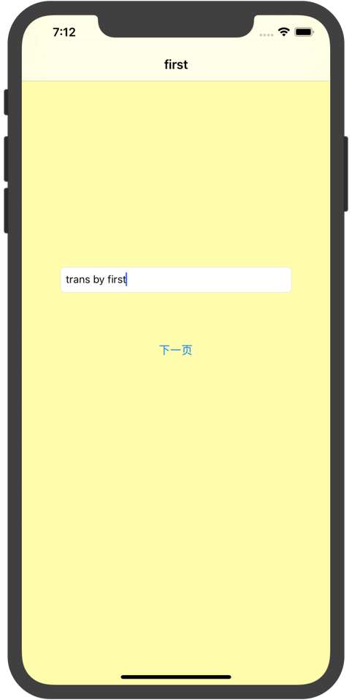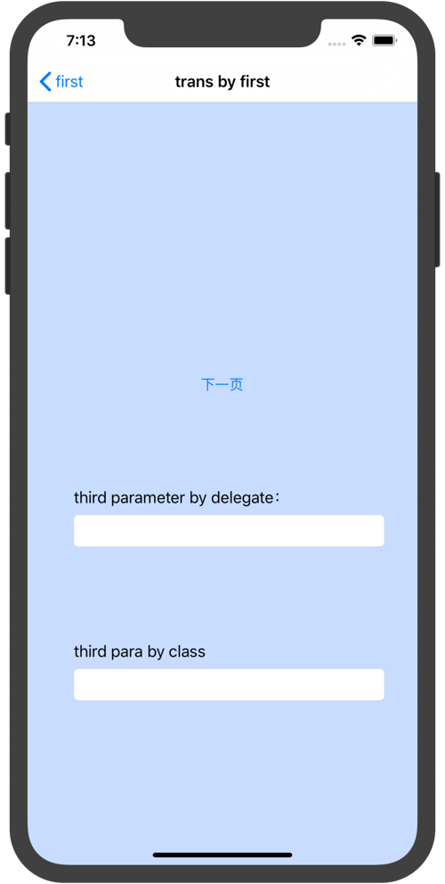

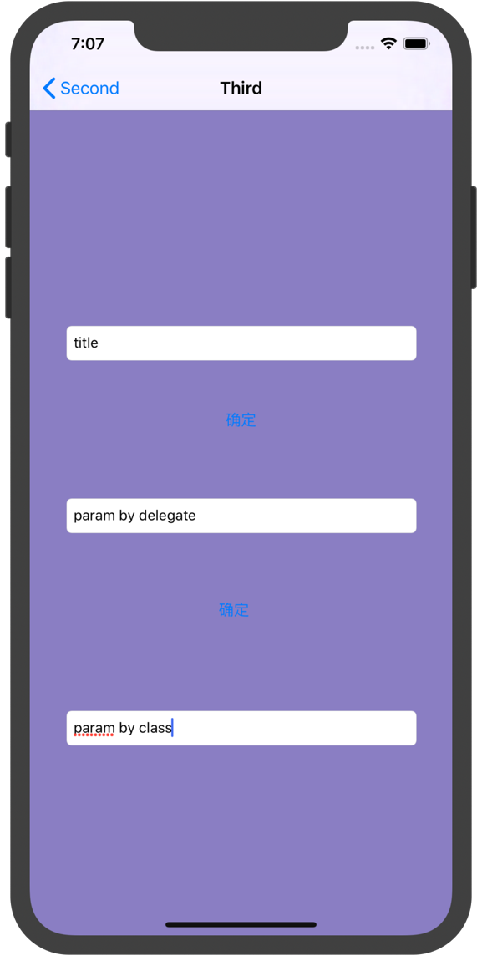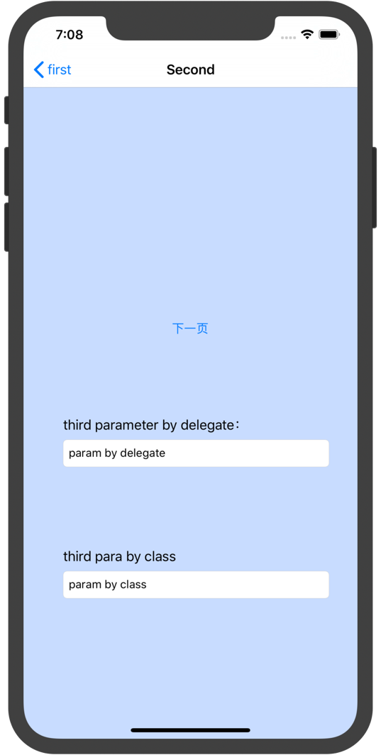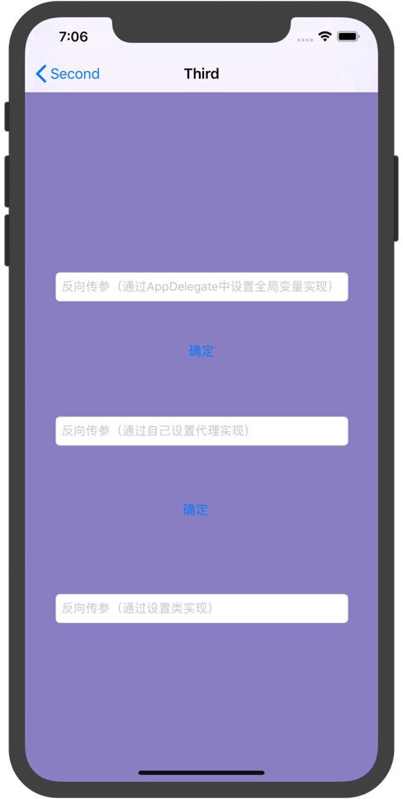

1. 完成苹果官网的FoodTracker Demo（多MVC）
   1. TableView（自定制Cell）；
   2. NavigationController；
   3. Modal Controller;
   4. ImagePickerController;

说明：苹果官网Demo网址如下

<https://developer.apple.com/library/content/referencelibrary/GettingStarted/DevelopiOSAppsSwift/index.html>

### 部分代码如下：

**MealTableViewCell**

**class** MealTableViewCell: UITableViewCell {

**@IBOutlet** **weak** **var** nameLabel: UILabel!

**@IBOutlet** **weak** **var** photoImageView: UIImageView!

**@IBOutlet** **weak** **var** ratingControl: RatingControl!

**override** **func** awakeFromNib() {

**super**.awakeFromNib()

// Initialization code

}

**override** **func** setSelected(**_** selected: Bool, animated: Bool) {

**super**.setSelected(selected, animated: animated)

// Configure the view for the selected state

}

}

**MealTableViewController**

**class** MealTableViewController: UITableViewController {

//MARK: **Properties**

**var** meals = [Meal]()

**override** **func** viewDidLoad() {

**super**.viewDidLoad()

navigationItem.leftBarButtonItem = editButtonItem

// Load any saved meals, otherwise load sample data.

**if** **let** savedMeals = loadMeals() {

meals += savedMeals

}

**else** {

// Load the sample data.

loadSampleMeals()

}

}

**override** **func** didReceiveMemoryWarning() {

**super**.didReceiveMemoryWarning()

// Dispose of any resources that can be recreated.

}

**override** **func** numberOfSections(in tableView: UITableView) -> Int {

**return** 1

}

**override** **func** tableView(**_** tableView: UITableView, numberOfRowsInSection section: Int) -> Int {

**return** meals.count

}

**override** **func** tableView(**_** tableView: UITableView, cellForRowAt indexPath: IndexPath) -> UITableViewCell {

**let** cellIdentifier = "MealTableViewCell"

**guard** **let** cell = tableView.dequeueReusableCell(withIdentifier: cellIdentifier, for: indexPath) **as**? MealTableViewCell **else** {

fatalError("The dequeued cell is not an instance of MealTableViewCell.")

}

**let** meal = meals[indexPath.row]

cell.nameLabel.text = meal.name

cell.photoImageView.image = meal.photo

cell.ratingControl.rating = meal.rating

**return** cell

}

// Override to support conditional editing of the table view.

**override** **func** tableView(**_** tableView: UITableView, canEditRowAt indexPath: IndexPath) -> Bool {

// Return false if you do not want the specified item to be editable.

**return** **true**

}

// Override to support editing the table view.

**override** **func** tableView(**_** tableView: UITableView, commit editingStyle: UITableViewCellEditingStyle, forRowAt indexPath: IndexPath) {

**if** editingStyle == .delete {

// Delete the row from the data source

meals.remove(at: indexPath.row)

saveMeals()

tableView.deleteRows(at: [indexPath], with: .fade)

} **else** **if** editingStyle == .insert {

// Create a new instance of the appropriate class, insert it into the array, and add a new row to the table view

}

}

**override** **func** prepare(for segue: UIStoryboardSegue, sender: **Any**?) {

**super**.prepare(for: segue, sender: sender)

**switch**(segue.identifier ?? "") {

**case** "AddItem":

os_log("Adding a new meal.", log: OSLog.default, type: .debug)

**case** "ShowDetail":

**guard** **let** mealDetailViewController = segue.destination **as**? MealViewController **else** {

fatalError("Unexpected destination: \(segue.destination)")

}

**guard** **let** selectedMealCell = sender **as**? MealTableViewCell **else** {

fatalError("Unexpected sender: \(sender)")

}

**guard** **let** indexPath = tableView.indexPath(for: selectedMealCell) **else** {

fatalError("The selected cell is not being displayed by the table")

}

**let** selectedMeal = meals[indexPath.row]

mealDetailViewController.meal = selectedMeal

**default**:

fatalError("Unexpected Segue Identifier; \(segue.identifier)")

}

}

//MARK: **Actions**

**@IBAction** **func** unwindToMealList(sender: UIStoryboardSegue) {

**if** **let** sourceViewController = sender.source **as**? MealViewController, **let** meal = sourceViewController.meal {

**if** **let** selectedIndexPath = tableView.indexPathForSelectedRow {

// Update an existing meal.

meals[selectedIndexPath.row] = meal

tableView.reloadRows(at: [selectedIndexPath], with: .none)

}

**else** {

// Add a new meal.

**let** newIndexPath = IndexPath(row: meals.count, section: 0)

meals.append(meal)

tableView.insertRows(at: [newIndexPath], with: .automatic)

}

// Save the meals.

saveMeals()

}

}

//MARK: **Private Methods**

**private** **func** loadSampleMeals() {

**let** photo1 = UIImage(named: "meal1")

**let** photo2 = UIImage(named: "meal2")

**let** photo3 = UIImage(named: "meal3")

**guard** **let** meal1 = Meal(name: "Caprese Salad", photo: photo1, rating: 4) **else** {

fatalError("Unable to instantiate meal1")

}

**guard** **let** meal2 = Meal(name: "Chicken and Potatoes", photo: photo2, rating: 5) **else** {

fatalError("Unable to instantiate meal2")

}

**guard** **let** meal3 = Meal(name: "Pasta with Meatballs", photo: photo3, rating: 3) **else** {

fatalError("Unable to instantiate meal2")

}

meals += [meal1, meal2, meal3]

}

**private** **func** saveMeals() {

**let** isSuccessfulSave = NSKeyedArchiver.archiveRootObject(meals, toFile: Meal.ArchiveURL.path)

**if** isSuccessfulSave {

os_log("Meals successfully saved.", log: OSLog.default, type: .debug)

} **else** {

os_log("Failed to save meals...", log: OSLog.default, type: .error)

}

}

**private** **func** loadMeals() -> [Meal]? {

**return** NSKeyedUnarchiver.unarchiveObject(withFile: Meal.ArchiveURL.path) **as**? [Meal]

}

}



**五、.实验结果的分析与评价（该部分如不够填写，请另加附页）**

1. 通过此次实验我再次使用了UINavigationController和UITabBarController，我更加熟悉了多mvc的设计实现。
2. 学会了通过Prepare方法进行正向传参
3. 使用了三种方式进行反向传参，设置一个类，使用代理，通过全局变量三种方式。实验后，还是不太理解使用代理反向传参的方式。

注：实验成绩等级分为（90－100分）优，（80－89分）良，(70-79分)中，（60－69分）及格，（59分）不及格。